

BOWMEN OF WARFIELD
UK RECORD STATUS
SHORT METRIC TOURNAMENT
SUNDAY 4TH SEPTEMBER 2022

Venue: Bowmen of Warfield, Hill Farm Lane, Binfield, Berks, RG42 5NR
(this is not a postal address – please do not send entries to this address)

Judge: Mr Andy Turner

Timings: Equipment inspection from 10am. Assembly 11am. Sighters 11.15am

Awards: Medals to 1st, 2nd and 3rd placings.

Age Groups (please indicate on entry form if a master, age is on day of event)
Ladies and Gents up to 49 years of age inclusive.
Masters (Ladies and Gents) from 50 to 59 years of age
Masters (Ladies and Gents) from 60 to 69 years of age
Masters (Ladies and Gents) from 70 + years of age
Novices (no age limit) Archers who have completed a beginner’s course in 2021

Team awards – Teams are based on the best 4 club members at the end of scoring, a team must include at least one representative of the opposite sex or a junior archer. Separate awards for each bow type.

Colour spot prizes – Gold / Red / Blue / Black / White / Green
Head to Head at the end of the shoot

Entry fee: £ 10.00 (£ 12.00 for entries after closing date) Refunds less £1.00 administration fee if notification of cancellation received on or before 25TH August 2022
To bank transfer please enter the reference SM followed by your name.
The Bowmen of Warfield bank account is at Lloyds Bank, Sort Code 30-63-54, Account 23500560.
Please make cheques payable to ‘Bowmen of Warfield’.

Closing date: 25th August 2022 or when full

Contact: Laura Tudor, 5 Bluethroat Close, Sandhurst, Berkshire. GU47 0XT. Tel: 07794 502308
Email: Laura@loznfil.uk Telephone: 07794 502308

Dress code: Archery GB dress regulations will apply
(No blue denim, olive drab or camouflage clothing, no non-archery logos)

Archery GB Cards: All archers must show a current Archery GB membership card at registration.

Equipment inspection: As this is a record status shoot, all equipment must be inspected before assembly. Please have your bow ready for inspection by 10.45am.

Photographs: Anyone not wishing their image, or their child’s image to be taken should contact the organiser. Any images taken during the shoot cannot be displayed with names without permission from the people involved. Any photograph taken by the Bowmen of Warfield official photographer may be used to promote future events, in our publications, by Archery GB and Archery GB publications.

Drug Testing: Archers competing at Record Status tournaments will be liable for drug testing, and competitors approached to give samples must comply. If the archer refuses this will be treated as a positive result. For Junior archers (Under 18) the entry form should be signed by the parent / guardian acknowledging their consent for the child to be drug tested.

No smoking/ No dogs: | Bowmen of Warfield have a no smoking policy on the archery field and dogs are not allowed at any of our events.
Parking: | Car parking at Binfield F.C. next to the club. Disabled parking at the archery club.
Refreshments: | To be confirmed depending on Covid status at the time.
Disclaimer: | Neither the organiser, Bracknell Forest Borough Council, the Bowmen of Warfield or Binfield F.C. can accept responsibility for any loss, damage or injury however caused
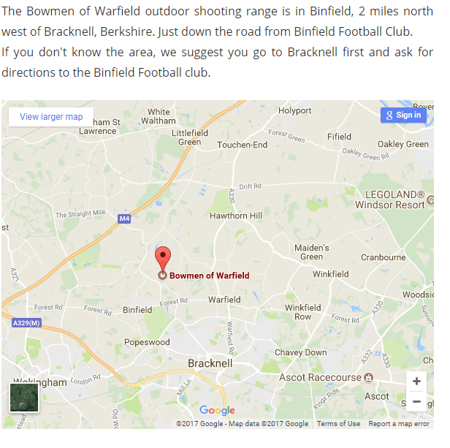

BOWMEN OF WARFIELD SHORT METRIC
SUNDAY 4TH SEPTEMBER 2022 ENTRY FORM

Given name |  |  |  |  | Family name |  | Lady (L) or  Gent (G) | Archery GB number | Bow  style* |  | Wheel chair or seated archer  Y/N |  |  | Master  50-59 |  | Master  60-69 |  | Master  70+ | Fee **
* B – Barebow / C – Compound / L – Longbow / R – Recurve

If you have any special requirements please write them here:______________________________________________________________________________________________________
DATA COLLECTED FOR THIS TOURNAMENT WILL ONLY BE USED FOR THE PURPOSE OF ORGANISING THE EVENT, ALL PERSONAL INFORMATION WILL BE SECURLY DISPOSED OF AFTER THE EVENT. BY SIGNING THIS FORM YOU AGREE TO THE ORGANISER HOLDING THE FOLLOWING INFORMATION.
CLUB: |  | SIGNATURE:  (agreeing that all of the above  agree to the tournament rules)
SENDER:

ADDRESS:

TELEPHONE CONTACT: | EMAIL ADDRESS:  ( Please print)

Please tick box if paying by bank transfer
Please post entry form to Tournament Organiser: Laura Tudor, 5 Bluethroat Close, Sandhurst, Berkshire GU47 0XT.
Results will be sent by email, should you require a printed copy please enclose a stamped addressed envelope with entry form.

THANK YOU FOR ENTERING, WE HOPE YOU HAVE A GOOD DAY. LOOKING FORWARD TO SEEING YOU ON THE 4th September 2022

