

BOWMEN OF WARFIELD
UK RECORD STATUS
JUNIOR SHORT METRIC TOURNAMENT
SATURDAY 11TH JUNE 2022

Venue: Bowmen of Warfield, Hill Farm Lane, Binfield, Berks, RG42 5NR
(this is not a postal address – please do not send entries to this address)

Judge: Mr Andy Turner

Timings: Equipment inspection from 10am. Assembly 11am. Sighters 11.15am

Rounds: Short metric 1 Junior ladies over 18 Junior gents over 16 3 doz at 50m, 3 doz at 30m
Short metric 2 Junior ladies under 18 Junior gents under 16. 3 doz at 40m, 3 doz at 30m
Short metric 3 Junior ladies under 16 Junior gents under 14 3 doz at 30m, 3 doz at 20m
Short metric 4 Junior ladies under 14 Junior gents under 12 3 doz at 20m, 3 doz at 10m
Short metric 5 Junior ladies under 12 3 doz at 15m, 3 doz at 10m

Bow types: Compound, recurve, barebow and longbow.

Medals: Medals will be awarded to 1st,2nd and 3rd in each category.
Team medals for 4 archers shooting the same bow style from the same club.

Other awards: Best archer for each bow type
Colour spot prizes - gold, red, blue, black, white and green!
Head to head fun round after the main competition.

Entry fee: £ 10.00 (£ 12.00 for entries after closing date)

Online payments: Bowmen of Warfield account details: Sort Code 30-63-54, Account 23500560.
Please use JSM and your surname as a reference if paying online.
If paying by cheque , make payable to ‘Bowmen of Warfield’

Address for entries: Laura Tudor, 5 Bluethroat Close, Sandhurst, Berkshire GU47 0XT

Email: laura@loznfil.uk

Telephone: 07794 502308

Dress code: Archery GB dress regulations will apply
(No blue denim, olive drab or camouflage clothing, no non-archery logos)

Archery GB Cards: All archers must show a current Archery GB membership card at registration.

Equipment inspection: As this is a record status shoot, all equipment must be inspected before assembly. Please have your bow ready for inspection by 10.45am.

Photographs: Anyone not wishing their image, or their child’s image to be taken should contact the organiser. Any images taken during the shoot cannot be displayed with names without permission from the people involved. Any photograph taken by the Bowmen of Warfield official photographer may be used to promote future events, in our publications, by Archery GB and Archery GB publications.

Drug Testing: Archers competing at Record Status tournaments will be liable for drug testing, and competitors approached to give samples must comply. If the archer refuses this will be treated as a positive result. The entry form should be signed by the parent / guardian acknowledging their consent for the child to be drug tested.

No smoking/ No dogs: | Bowmen of Warfield have a no smoking or vaping policy on the archery field and dogs are not allowed at any of our events.
Parking: | Car parking at Binfield F.C. next to the club. Disabled parking at the archery club.
Refreshments: | To be confirmed depending on Covid status at the time.

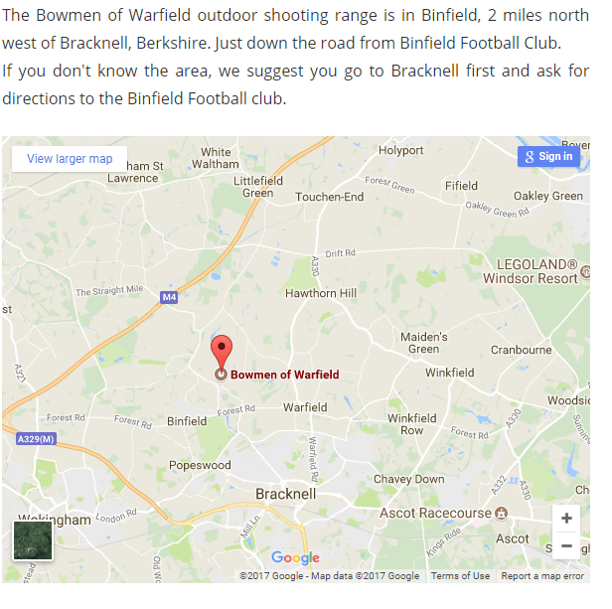

BOWMEN OF WARFIELD JUNIOR SHORT METRIC
SATURDAY 11TH JUNE 2022 ENTRY FORM

Given name |  |  |  |  | Family name |  | Lady (L) or  Gent (G) | Date of birth | Archery GB number | Bow  style* |  | Wheel chair or seated archer  Y/N |  |  | Short Metric 1 |  | Short Matric 2 |  | Short Metric 3 |  | Short Metric 4 |  | Short Metric 5 |  | Fee **
* B – Barebow / C – Compound / L – Longbow / R – Recurve
If you have any special requirements please write them here:______________________________________________________________________________________________________
DATA COLLECTED FOR THIS TOURNAMENT WILL ONLY BE USED FOR THE PURPOSE OF ORGANISING THE EVENT, ALL PERSONAL INFORMATION WILL BE SECURLY DISPOSED OF AFTER THE EVENT. BY SIGNING THIS FORM YOU AGREE TO THE ORGANISER HOLDING THE FOLLOWING INFORMATION.
CLUB: |  | SIGNATURE:  (agreeing that all of the above  agree to the tournament rules)
SENDER:

ADDRESS:

TELEPHONE CONTACT: | EMAIL ADDRESS:  ( Please print)

Please tick box if paying by bank transfer
Please post entry form to Tournament Organiser: Laura Tudor, 5 Bluethroat Close, Sandhurst, Berkshire GU47 0XT.
Results will be sent by email, should you require a printed copy please enclose a stamped addressed envelope with entry form.

THANK YOU FOR ENTERING, WE HOPE YOU HAVE A GOOD DAY. LOOKING FORWARD TO SEEING YOU ON THE 11th June 2022

